

**ASEPSIS**

**(SMART DUSTBIN MONITORING SYSTEM**

**WITH SENSORS AND ARDUINO)**

**SUBMITTED TO:**

Dr. DURGANSH SHARMA  
Assistant Professor (SS) Department Of Computer Application

**SUBMITTED BY-:**

|  |  |  |  |
| --- | --- | --- | --- |
| **COURSE** | **Name** | **Sap ID** | **Enroll NO.** |
| **BCA** | **HIMANSHU JAISWAL** | **500066529** | **R174218017** |
| **BCA** | **VAIBHAV MISHRA** | **500066709** | **R174218064** |
| **BCA** | **SPARSH AGARWAL** | **500069350** | **R174218091** |
| **BCA** | **ROHAN VIJAY** | **500071423** | **R174218079** |

**INDEX**

* Agile Manifesto.................................................2
* Introduction.......................................................3
* Outcome............................................................5
* Entity Relation Diagram...................................6
* Data Flow Diagram...........................................7
* PERT Chart......................................................11
* State chart.........................................................12
* Sequence Diagram............................................13
* Class Diagram..................................................15
* Use of Agile Methodology...............................17

**AGILE MANIFESTO**

The following 12 Principles are based on the [Agile Manifesto](https://www.agilealliance.org/agile101/the-agile-manifesto/).

1. Our highest priority is to satisfy the customer through early and continuous delivery of valuable software.

2. Welcome changing requirements, even late in development. Agile processes harness change for the customer’s competitive advantage.

3. Deliver working software frequently, from a couple of weeks to a couple of months, with a preference to the shorter timescale.

4. Business people and developers must work together daily throughout the project.

5. Build projects around motivated individuals. Give them the environment and support they need, and trust them to get the job done.

6. The most efficient and effective method of conveying information to and within a development team is face-to-face conversation.

7. Working software is the primary measure of progress.

8. Agile processes promote sustainable development. The sponsors, developers, and users should be able to maintain a constant pace indefinitely.

9. Continuous attention to technical excellence and good design enhances agility.

10. Simplicity–the art of maximizing the amount of work not done–is essential.

11. The best architectures, requirements, and designs emerge from self-organizing teams.

12. At regular intervals, the team reflects on how to become more effective, then tunes and adjusts its behaviour accordingly.

**INTRODUCTION**

With the advancement in technology people are much more dependent on materialism. Use of materialistic things are common with people in their daily lives use of products like paper, plastic, vegetables peels etc are common litter, in order to collect these waste materials dustbins are used . But people are not careful enough and still they litter here and there, with these disease are likely to spread which can be epidemic

This article exhibits a Smart Solid Waste Monitoring and gathering framework. It is a typical sight to witness trash spilled out in and around the residue containers. The region around an inappropriately looked after residue receptacles can house illness spreading creepy crawlies like mosquitoes, flies, honey bees and driver ants. The earth around a dustbin is likewise favorable for expanding the contamination level in air. Air contamination because of a dustbin can create microscopic organisms and infection which can deliver life undermining infections in individuals. Extra consideration must be taken in a thickly populated region where the squander stores in the containers are adequately high.

Dustbin level is transmitted through server with the help of Ultrasonic sensor. At a time we can screen the dustbin all through the system. It implies we can get to the information from dustbin where all the work stations are associated with a similar system.

At regular intervals the information about the degree of trash in the dustbin is refreshed. After the dustbin is filled totally it is shipped by a vehicle to the landfill yard to keep the city clean. This plan is free of Worldwide System for Mobile Communication (GSM) what's more, consequently can be utilized in condos, ventures what's more, clinics.

The remainder of the article is composed as follows: Section 2 shows a short review on existing residue checking frameworks. Area 3 presents the square portrayal of the brilliant residue container observing framework;

Segment 4 spotlights on the equipment usage, while end and degree for future work are given in Section 5 and 6 separately.

**OUTCOME**

**Advantages:**

* In our framework if dustbin is moved to another migration it will consequently enlisted with the server with the new GPS area.
* It will save fuel and time using appropriate route planning.
* Keeps the environment clean and fresh.
* Reduces environmental pollution.
* Empowering ‘Swatch Bharat Abhiyaan’.
* Real time based cleaning of our locality, streets, cities etc.
* It makes our system transparent between the Municipal Corporation, workers and public.

**Disadvantages:**

* Garbage separation is difficult.
* The process is not always cheap.

**Future Scope:**

* The project is just a demo and is likely to be taken at product level.
* It can be made durable, by making it compact and cheap.
* Two bins can be placed in order to collect wet and dry waste, thus garbage separation problem can be overcomed.
* Wet waste can be decayed to produce biogas.

**Entity Relation Diagram**

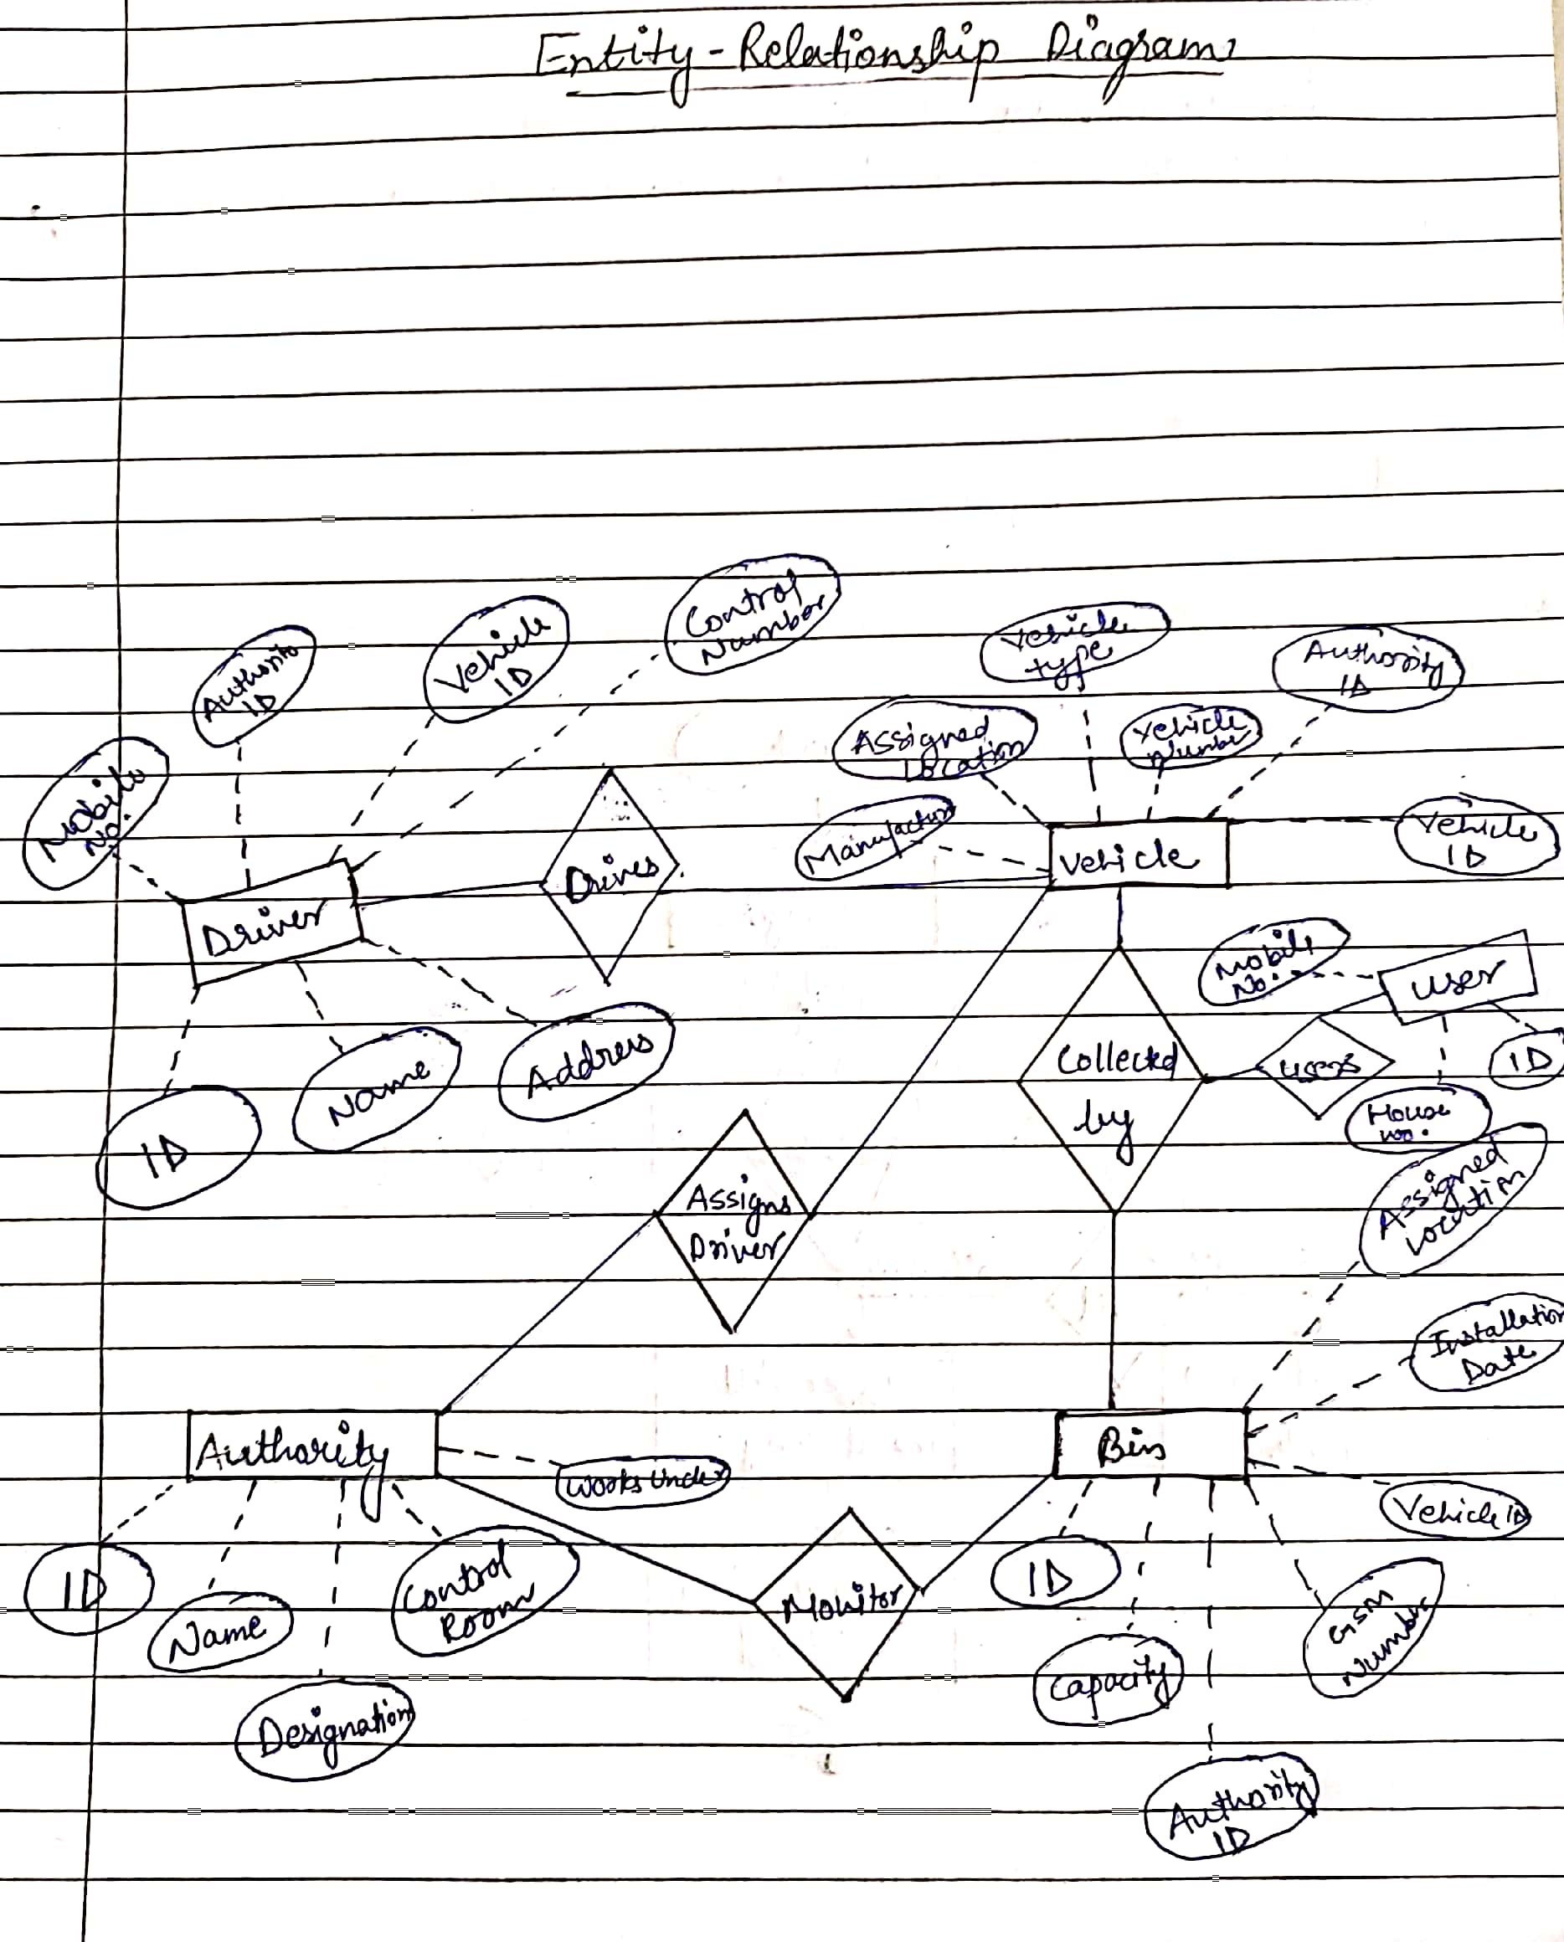

## Entity Relationship diagram

An entity relationship model, also called an entity relationship(ER)d diagram is a graphical representation of entities and their relationships to each other typically used in computing in regard to the organization of data within databases or in regard to the organization of data within databases or information systems. This model allows to sketch the design of a database informally

**Data Flow Diagram**

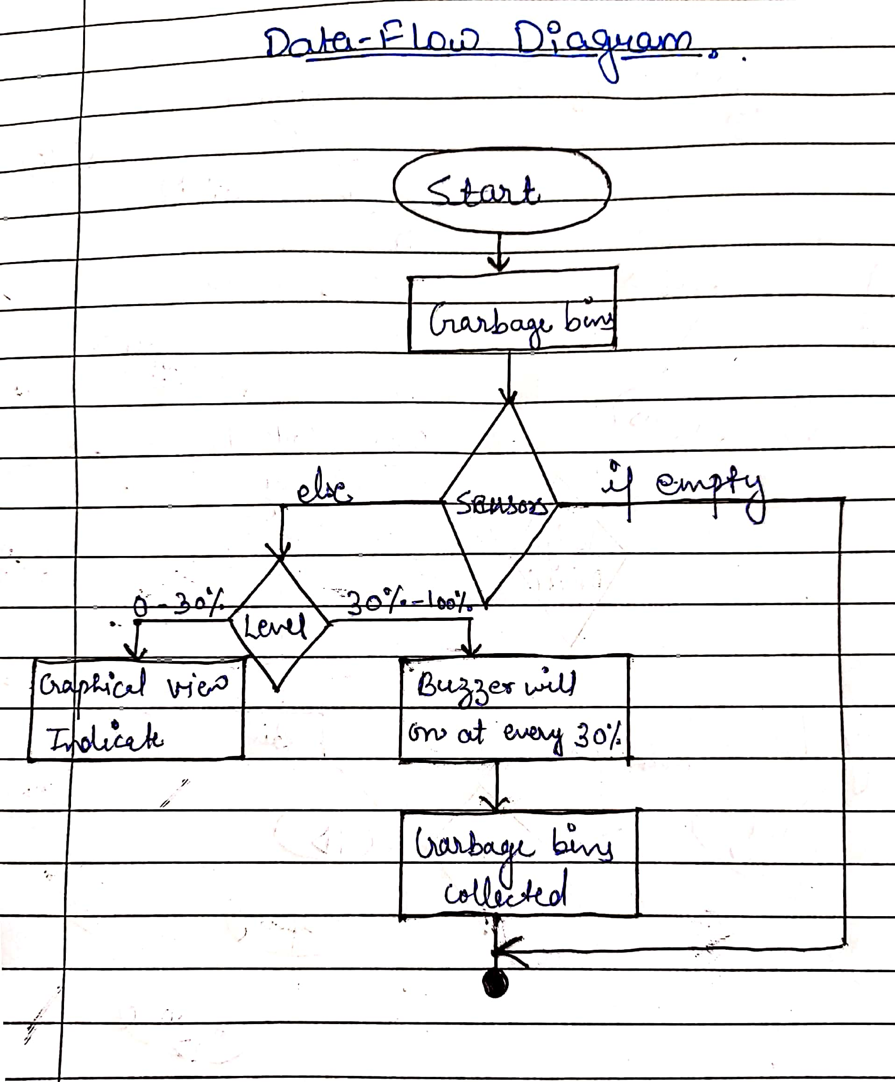

**DFD Level -0**

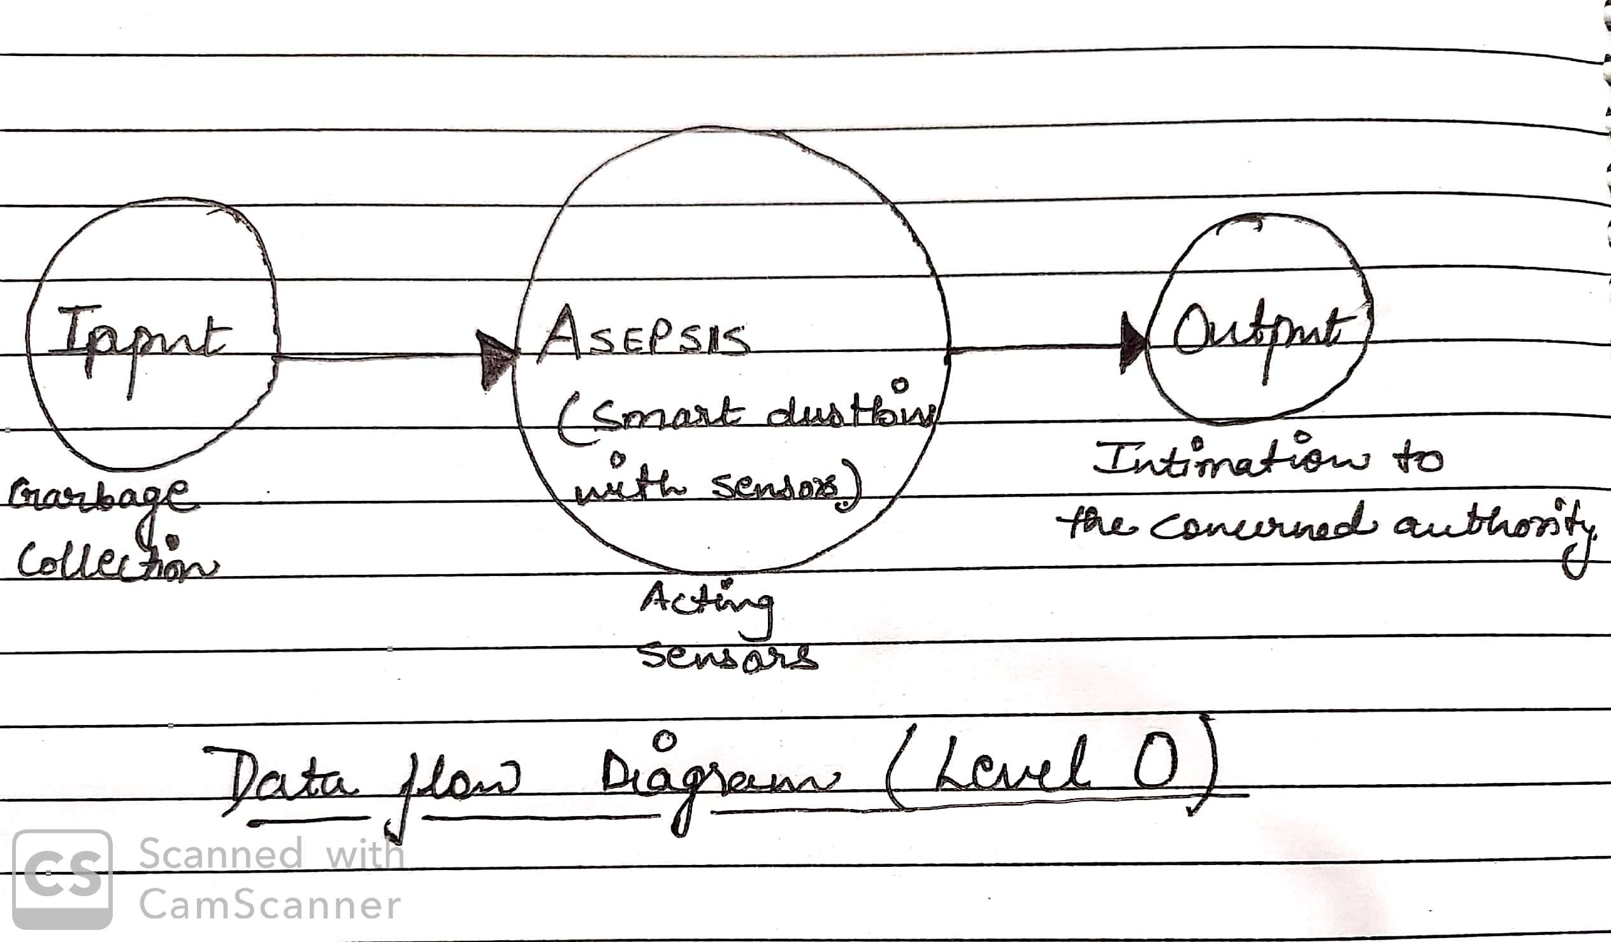

**DFD Level -1**

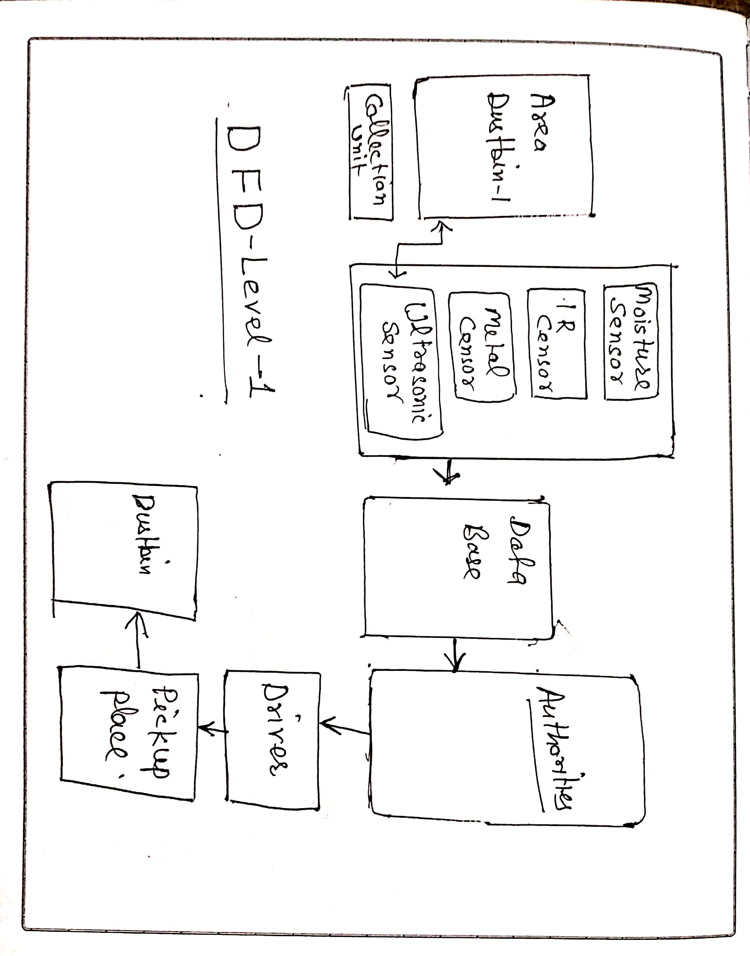

**PERT Chart**

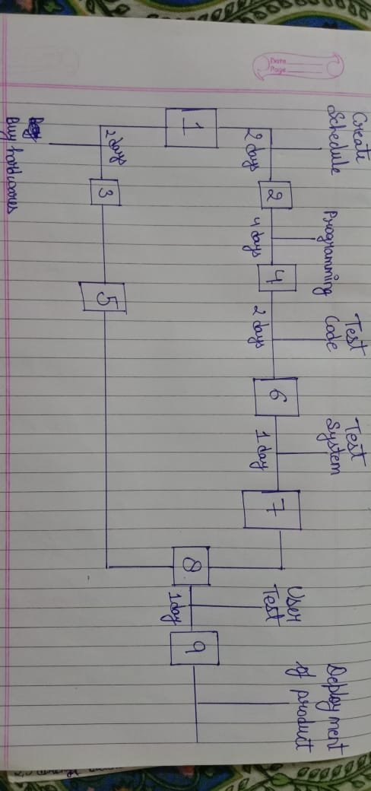

**STATE CHART**

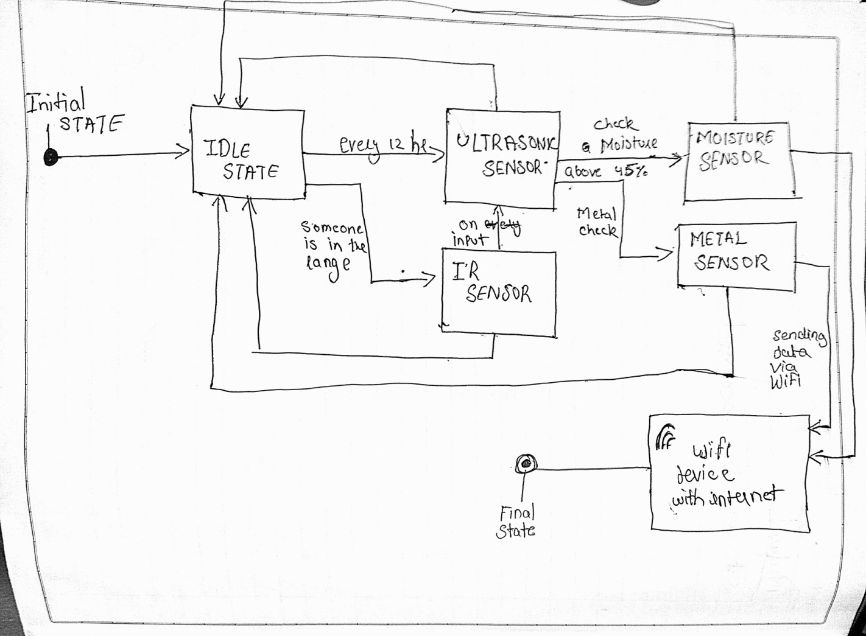

**Sequence Diagram**

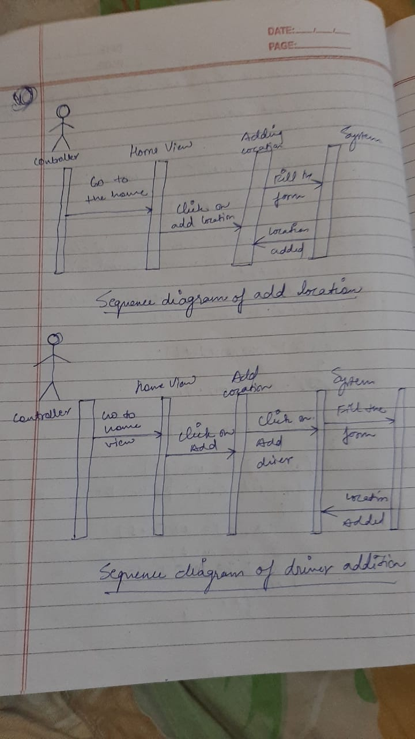

**Sequence Diagram**

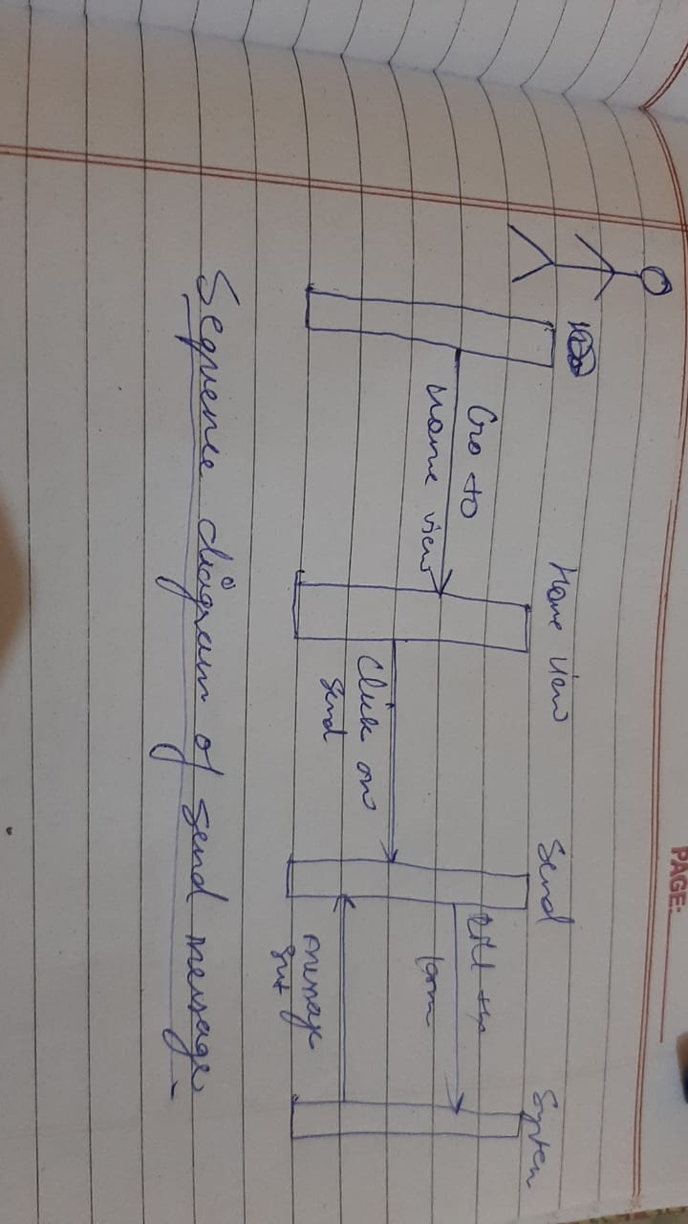A sequence diagram is an interaction diagram that shows how objects operate with one another and in what order. It is a construct of a Message Sequence Chart. A sequence diagram shows object interactions arranged in time sequence. It depicts the objects and classes involved in the scenario and the sequence of messages exchanged between the objects needed to carry out the functionality of the scenario. Sequence diagrams are typically associated with use case realizations in the Logical view of the system under development. Sequence diagrams are sometimes called event diagram or event scenarios. Below there are sequence diagram of the system.In figure below to add the garbage location to the controller go to the home view and click on Add button and then fill the form, after that the system responded that it add the location to the database

**Class Diagram**

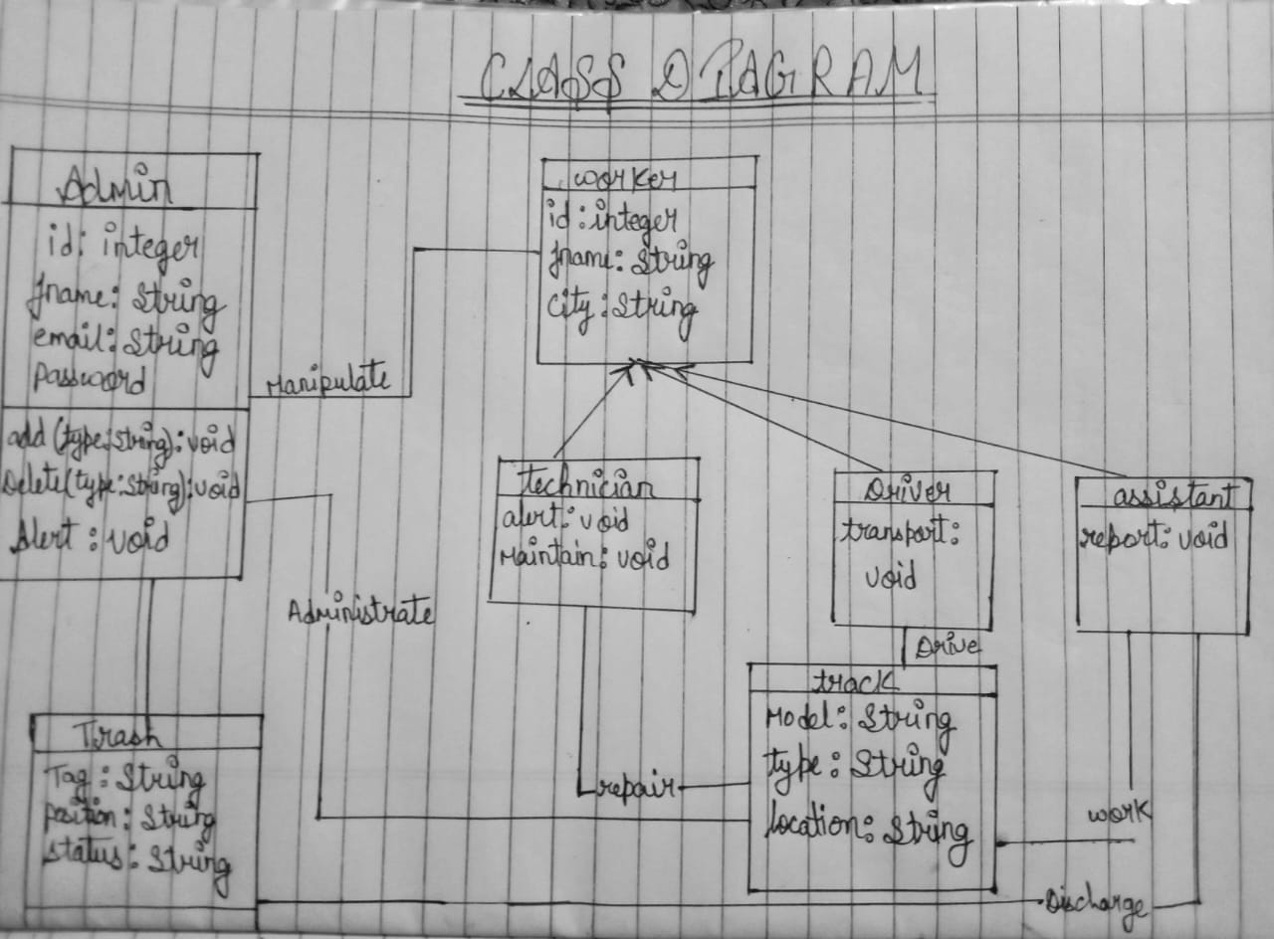

**Use Of Agile Methodology**

**Software Methodology**

For developing the software part of the system we use Rapid Application Development (RAD) model because this models takes iterative ideas to the extreme and instead of using iterations lasting years. The fig below shows the phase of RAD model.

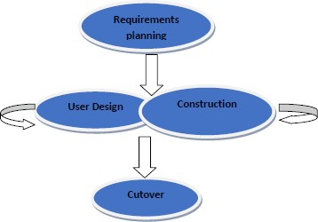

**Requirements planning**—the entire group member agrees on the project‗s objective on designing developing and implementing the graphical user interface at receiving part. The requirements are specified in a way that they don‗t restrict later developmental change.

**User design**—team members work together to convert the requirements into a functioning design.

**Construction**—all members of the group participate on building an application.

**Cutover**— lastly we provide a finished windows application

ERD –. Every sprint comes with a timeline that extends from 2 months to maximum 4 months. And each of them has these following components to make the [Asepsis-The Smart Dustbin](https://appinventiv.com/blog/reasons-why-we-trust-agile-for-our-mobile-app-development-process/) more efficient –

**1. Scrum Roles**

Product Manager – HIMANSHU JAISWAL is responsible for overlooking what the team is working on and is also responsible for ensuring that the backlog is up to date.

Scrum Master – VAIBHAV MISHRA is assigned to ensure that the agile scrum is followed rightly by the team. They are also responsible for overlooking how the team is performing and then resolving any issue that is coming up.

Scrum team –HIMANSHU, VAIBHAV, SPARSH, ROHAN are the ones who are actually doing the tasks. They own the development and testing part of the whole project.

**2. Product Backlog**

Handled by the product manager IAMNSHU’S job was to see product backlog, product backlog is a list of tasks that the team needs to perform. The modifications and priorities are set and controlled by the Scrum Master VAIBHAV which was forwarded to the scrum team and was then accordingly as and when needed.

* DFD LVL 0-
* DFD LEVEL 1-
* DFD LEVEL 2-
* PERT CHART-
* PROCESS FLOW DIAGRAM –
* STATE DIAGRAM-
* SEQUENCE DIAGRAM –
* CLASS DIAGRAM
* ABSTRACT VIEWS

**3. Agile Sprint Backlog and Planning**

In this scrum methodology step, the ADIRA team decides on the backlogs they will be targeting on in the current sprint. Sprint backlog is the list of things the team plans on achieving in the delivery. Usually, sprint backlogs are divided into workable actions and once the team agrees upon the backlog items, the sprint begins.

* ERD –COMPLETED
* DFD LVL 0- COMPLETED
* DFD LEVEL 1- COMPLETED
* DFD LEVEL 2-. COMPLETED
* PERT CHART- COMPLETED
* PROCESS FLOW DIAGRAM –COMPLETED
* STATE DIAGRAM- COMPLETED
* SEQUENCE DIAGRAM –COMPLETED
* CLASS DIAGRAM- COMPLETED
* ABSTRACT VIEWS- COMPLETED

### 4. Daily Scrum Meeting

Once the above steps of agile methodology are done and the team starts working on the product backlogs, a practice called daily scrum is initiated. A stand up daily meeting is held every day for 15 minutes. In the daily scrum everyone in the team tells about the last day’s work and the day’s plan. The daily scrum lets everyone in the team know of the whole project’s progress.

* Meeting at zoom where we discussed State Chart and state diagrams
* Meeting at zoom where we discussed Abstract views and Class diagrams
* Meeting at zoom where we discussed about sequence diagrams and methodology

**References**

* International Journal of Advances in Computer and Electronics Engineering, Vol. 2, April 2017, PP.20-23
* https://docplayer.net/99164088-Smart-trash-can-monitoring-system-using-iot-creating-solutions-for-smart-cities.html